ESC Social Media Posts – ESC 2025 Survey

Facebook & Instagram
Channel | Facebook & Instagram
Topic | Participate in the ESC Survey 2025

Text:
…………………..
📣 Take part in the 2025 #EuropeanStudentCard Survey!
With over 4 million issued European Student Cards, we’re growing fast! 🚀 We want to hear YOUR thoughts and suggestions to keep shaping the future of student mobility in Europe. 🌍
Last year, over 5,400 responses came in from 33 Erasmus+ countries. Help us go even further this year! 🌟
👉 Are you a higher education student, staff member, or student service provider in Europe? Your voice matters!
🕐 It only takes 10 minutes. Fill out the survey here: [https://ec.europa.eu/eusurvey/runner/ESC_Survey_2025 ] 🌐
👉 Survey open until 7 November 2025
#HigherEducation #ESC 🎓

Visual (also file attached):
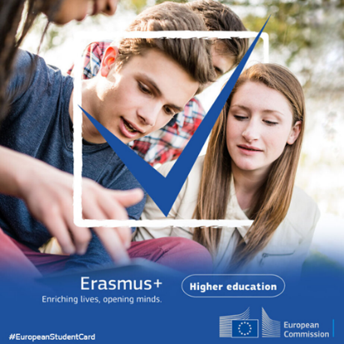

X – (Twitter)
Channel | X
Topic | Participate in the ESC Survey 2025

Text:
…………………. OPTION 1: Limit of Characters (280 admitted)
📣 Take part in the 2025 #EuropeanStudentCard Survey and help shape student mobility 🌍
👉 Are you a higher education student, staff, or student service provider in Europe? Share your thoughts in just 10 min!
https://ec.europa.eu/eusurvey/runner/ESC_Survey_2025
Open until 7 November
Visual (also file attached):
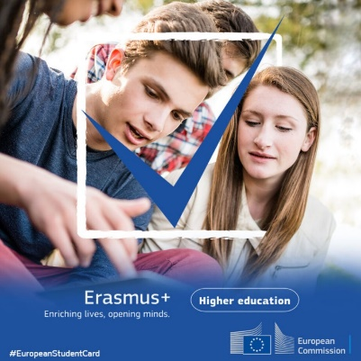
LinkedIn
Channel | LinkedIn
Topic | Participate in the ESC Survey 2025


📣 Check out the 2025 #EuropeanStudentCard Survey!
With over 4 million European Student Cards issued to date, the ESC is expanding 🚀Your feedback is essential to keep improving. 🌟 We’re inviting all current students and staff members from higher education institutions, as well as student service providers across the 33 #Erasmus+ Programme countries to share their insights and help shape the future of European mobility.
👉🏽 Quick 10-minute survey – open until 7 November 2025. Access it here: l https://ec.europa.eu/eusurvey/runner/ESC_Survey_2025
#EuropeanEducationArea #StudentMobility #HigherEducation

